To clone a Repo

Git clone “URL”

Then git add to add files to repo
Git add “choose files from the repository”
U can choose specific files or if u need everything use git add -all
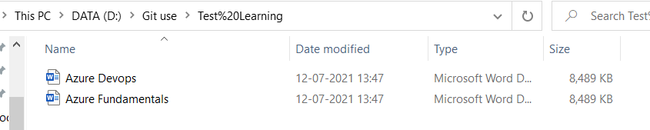

Then run commit..(this will commit all changes,, in our case it will commit the added file)
While commiting give -m with a message

git commit -m "created a word doc for learning"
Since user account is not added I got this error

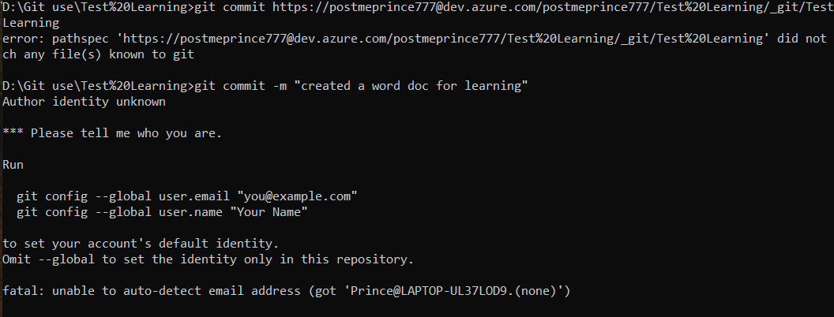

Then I ran the below commands
git config --global user.email postmeprince777@gmail.com
git config --global user.name "Prince"

git commit -m "created a word doc for learning" worked now.
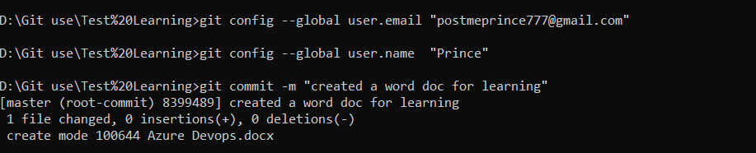

Then run git push
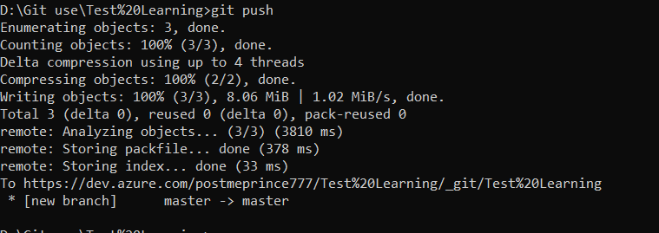
Now I can see the word doc in azure devops repo
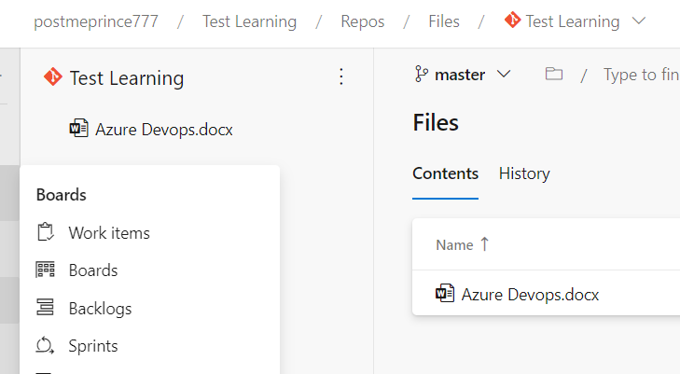

BRANCHES
You can create a new branch from azure devops portal
After creating a branch in server, u need to git pull to refresh that in local REPO

Then to switch branch in cmd, run git checkout “branchname”
To create new branch with git from cmd (local repository)
Git branch “newbranchname”
After creating, to sync it with server repo simple push command is not enough
U need to run
Git push –set-upstream origin “newbranchname”

